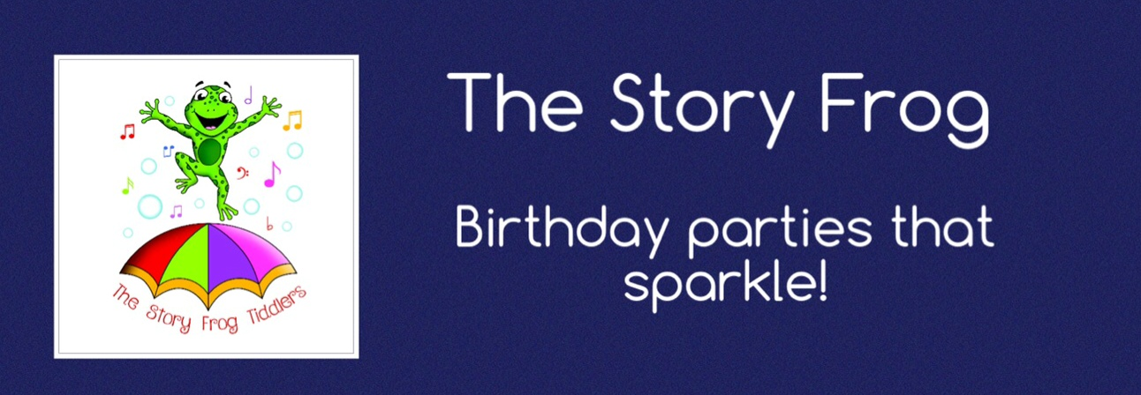

Thank you so much for enquiring about birthday parties with The Story Frog, we are so excited to begin working with you and start your Story frog adventure, this is where the fun begins….
In order for us to create your child’s perfect party, we need a few details.
Please fill in the form below, save it and attach it in and
e-mail to thestoryfrogsam@gmail.com

A bit about you so we can get back to you about your party:
Your name
Your address
Your phone number
When is the best time to call you?
How did you hear about The Story Frog?

Some information to help me plan a quotation for your child’s party:
Your child’s name
Your child’s age
What theme would you like for your party?
What story would you like the entertainer to read at the end of the party?
How many children will be at the party?
Is there anything extra we should know? (favourite games, songs, characters, like or dislikes)

A Story Frog Party comprises an hour of themed games and activities, followed by a story reading, which can work as a good wind-down before your party tea (The Story Frog are unable to provide catering). We can build a package from the following suggested activities so please indicate the ones you like the sound of below! These are just indicators and we can build more specific activities in keeping with your suggested theme.
Parachute games, bubbles, rainbow face paints | Included in all parties
Food activities
Themed biscuits to ice
Cupcakes to ice
Edible paints on marshmallows
Craft Activities
Finger painting
Balloon painting
Fruit painting
Butterfly painting
Sand dig
Jelly fishing
Mask making
Feather pictures
Sound shakers
Bead threading
Sand drawing
Sequin/glitter drawing
Is there anything extra we should know? (favourite games, songs, characters, like or dislikes)

Some information about the date, time and location of your party:
The date of your party
The time of your party
The location of your party
Is there somewhere for the entertainer to park their car?
Is there anything extra we should know? (favourite games, songs, characters, like or dislikes)

Thank you for taking the time to fill out this form. After we’ve read it through,
I’ll get right back to you with a plan and a quotation.

